- System Operation Sequence

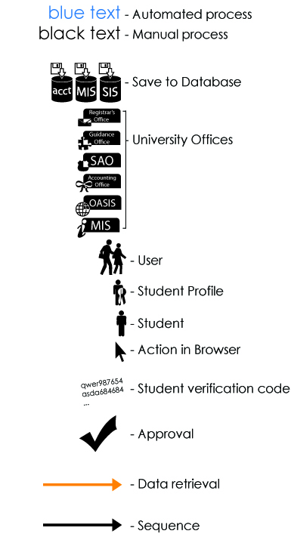

Figure 1 The above figure will serve as a legend for all the succeeding diagrams in System Operations Sequence section.
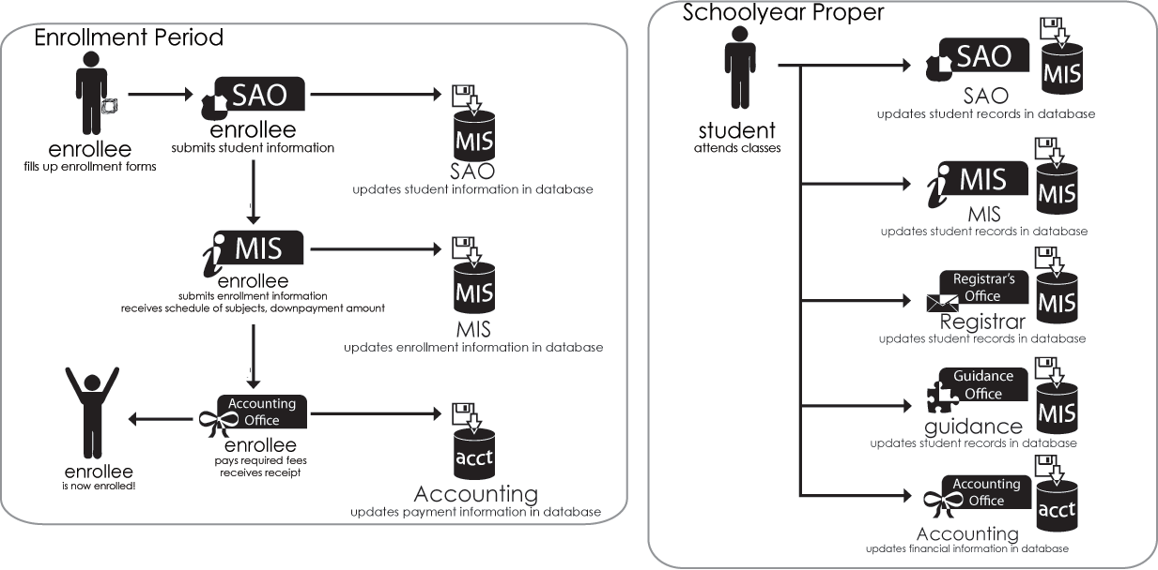

Figure 2 Presented above is Saint Louis University's Current System of acquiring student data and information. It starts during the enrolment period and runs through the rest of the school year.

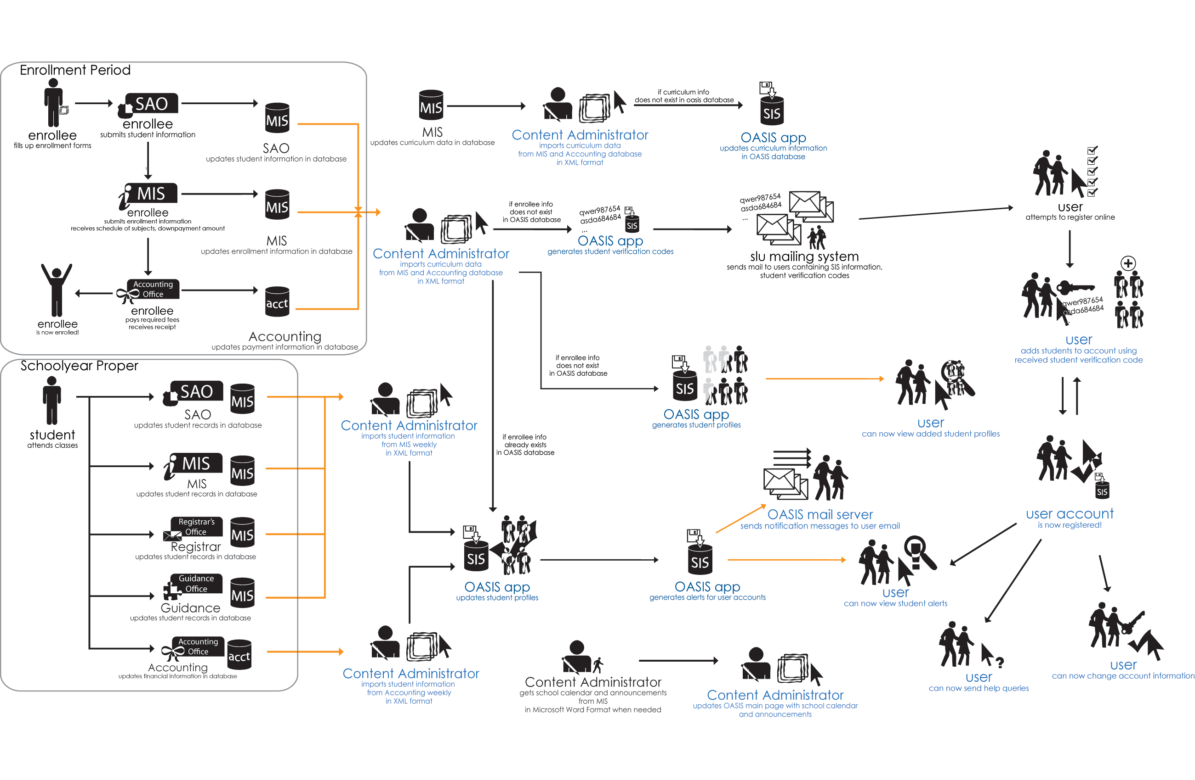
Figure 3 Presented above is the Proposed System for the Online Access Student Information System. As can be seen, the CA is the one responsible for most of the activities in the proposed system. Furthermore, the current system is not discarded from the process. Rather, OASIS is appended to the current system.
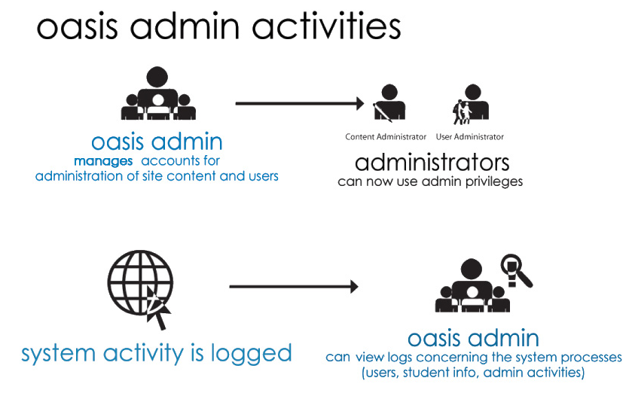
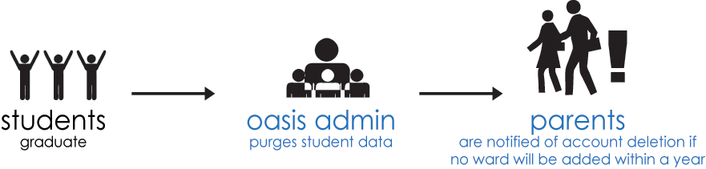

Figure 4 Presented above is the OASIS Administrator Activities. The OASIS Administrator has the combined privileges of the Content Administrator and User Administrator. Aside from this, it is the OASIS Administrator who can see the reports and statistics regarding the OASIS.

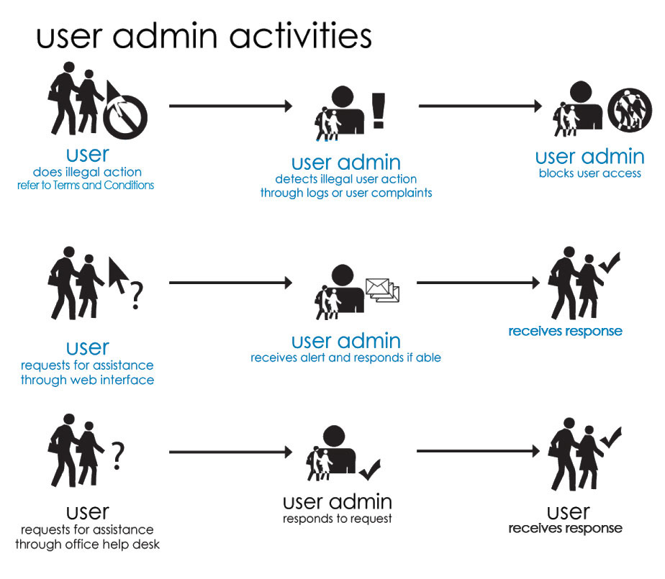
Figure 5 Presented above are the activities of the User Administrator. A User Administrator may block and unblock users. A User Administrator also has the responsibility of responding to requests and concerns of users.

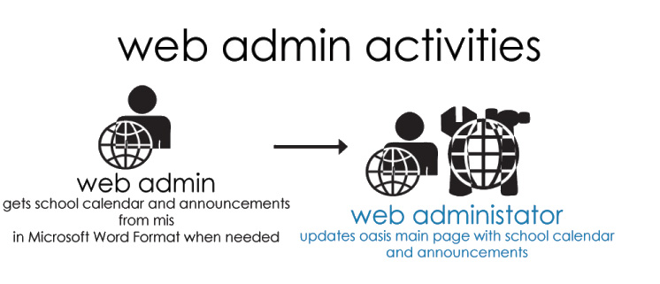
Figure 6 Presented above is the concise graphical representation of the activities of the Web Administrator.

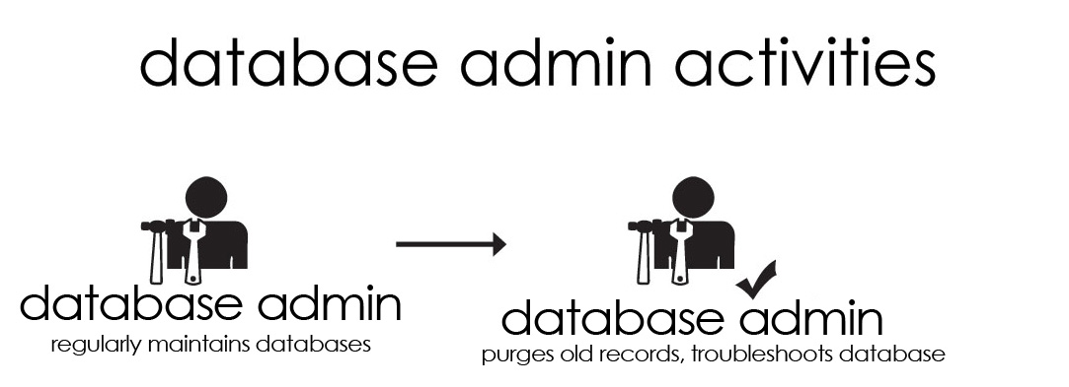
Figure 7 Presented above is the concise graphical representation of the activities of the Database Administrator.

